Credit Card Fraud Detection
Team 5
Hiteshi Kawadia | Preksha Praveen

Course: INFO 6105 - Data Science Engineering Methods and Tools (Spring 2026)
Dataset: Kaggle - Credit Card Fraud Detection

1. Introduction

1.1 Background
Credit card fraud is one of the most pressing and expensive challenges the financial industry must deal with. As digital payment usage increases worldwide, the volume and complexity of fraud activities has grown extensively. According to industry reports, credit card fraud accounts for billions of dollars in losses annually, affecting consumers, merchants, and financial institutions. There are two dominant forms of credit card fraud:
- Account takeover fraud, where a thief obtains a cardholder's credentials and makes unauthorized purchases on an existing account.
- New account fraud, where a thief opens a new line of credit using stolen personal information.
The scale of the problem is concerning. In the United States alone, fraud reports increased dramatically in recent years, reflecting how rapidly fraudsters have adapted their methods to exploit new digital payment methods. With an estimated 2.8 billion credit card users globally, even a fraction of a percent of fraudulent transactions translates to an enormous financial and operational burden.
Traditional fraud detection systems relied heavily on rule-based approaches which are manually defined thresholds and conditions such as flagging transactions above a certain dollar amount or originating from unusual locations. The current systems often suffer from high false positive rates, which can frustrate legitimate customers or high false negative rates, which allow fraud to go undetected. While these methods provide a baseline of protection, they suffer from limitations: they are rigid and slow to update, they generate high volumes of false positives that frustrate legitimate customers, and they are easily bypassed by smart fraudsters who understand the rules in place. As fraud tactics evolve at high speed, static rule sets cannot keep pace.
Machine learning offers a fundamentally better approach. Instead of encoding pre-defined rules, ML models learn the statistical patterns of fraudulent behavior directly from historical transaction data. They can identify subtle, nonlinear patterns across dozens of features simultaneously, even patterns that no human analyst could explicitly define. Moreover, ML models can be retrained continuously as new fraud patterns emerge, providing an adaptive defense that improves over time.

1.2 Motivation
The main motivation for this project is that this is a critical real-world with real consequences. The need to protect both consumers and financial institutions from the financial and psychological harm caused by fraud is an issue that must be addressed immediately. Beyond the financial loss, fraud damages customer’s trust in digital payment systems which is foundationa to the modern economy and technology.
From a data science perspective, credit card fraud detection presents one of the most challenging and yet helpful problem settings in the field: extreme class imbalance. In most real-world datasets, fraudulent transactions account for less than 0.2% of total transactions. This means that an simple model that always predicts "legitimate" achieves over 99.8% accuracy while detecting zero fraud cases, making standard accuracy completely meaningless as an evaluation metric. This project addresses this challenge directly, applying advanced imbalance handling techniques and appropriate evaluation metrics.

1.3 Goal
The goal of this project is to develop, train and rigorously evaluate a complete end-to-end machine learning pipeline for credit card fraud detection. Specifically, we aim to:
- Perform deep exploratory data analysis (EDA) to understand what separates fraud from legitimate transactions before we even touch a model.
- Build a preprocessing pipeline that handles all data issues efficiently including feature engineering, scaling and class imbalance handling via SMOTE, in the right order to avoid data leakage.
- Train and compare the four chosen classification models: Logistic Regression, Decision Tree, Random Forest and K-Nearest Neighbors.
- Evaluate all models using metrics appropriate for imbalanced classification: Precision, Recall, F1-Score, and ROC-AUC rather than accuracy.
- Identify the best-performing model and explain why, with a practical business perspective on how it would actually be used.

2. Methodology
Our project follows a structured, reproducible workflow consisting of six phases:
- Data loading and exploration
- Exploratory data analysis
- Data preprocessing
- Model building
- Model evaluation
- Model comparison

2.1 Data Loading and Exploration

We load the dataset using pandas and run a few basic checks before doing anything else. The dataset has 284,807 rows and 31 columns, all numeric: 30 float64 and 1 int64 (Class). There are no missing values anywhere, so no imputation is needed. We found 1,081 duplicate rows using df.duplicated() and flagged them for removal. A quick df.describe() showed the Class mean of 0.0017 confirming the severe imbalance, and the Amount column had a wide range (0 to $25,691) indicating it would need scaling. The V1–V28 features all had means close to zero and standard deviations around 1–2, consistent with PCA-transformed data which means no scaling would be needed for them.

2.2 Exploratory Data Analysis (EDA)
Before building any model, we conducted a comprehensive EDA to understand the dataset's structure, identify data quality issues and uncover patterns that distinguish fraudulent from legitimate transactions.
Class Distribution Analysis: We first visualized the severe class imbalance: 99.83% legitimate vs. 0.17% fraudulent transactions. This confirmed that standard accuracy would be a meaningless metric and that class imbalance handling was priority.
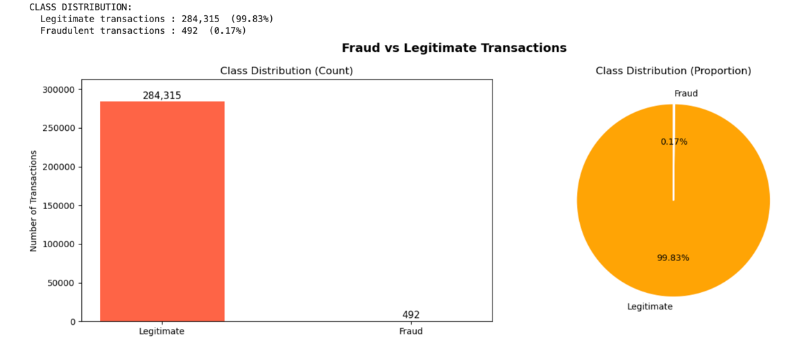
Transaction Amount Analysis: We compared the distribution of transaction amounts between fraud and legitimate cases using normalized histograms and box plots. Fraudulent transactions showed a notably lower median amount ($9.25) compared to legitimate transactions ($22.00), supporting the known pattern that fraudsters keep transaction amounts small to avoid triggering detection systems.
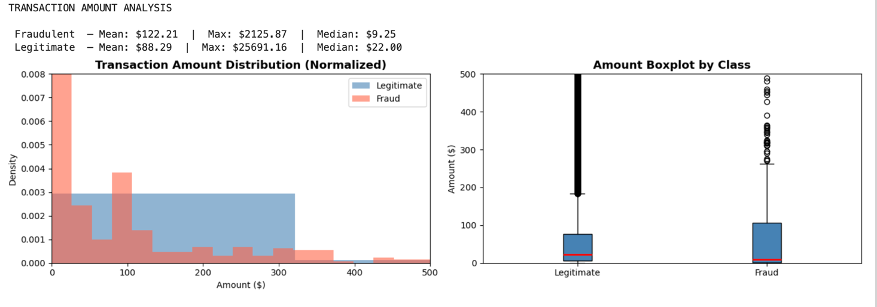
Transaction Time Analysis: We converted the raw Time feature (seconds elapsed since the first transaction) into an Hour-of-Day feature (0–23) to make it interpretable. This revealed that fraud clusters at specific hours, particularly late night and early morning when fraud monitoring may be less active.

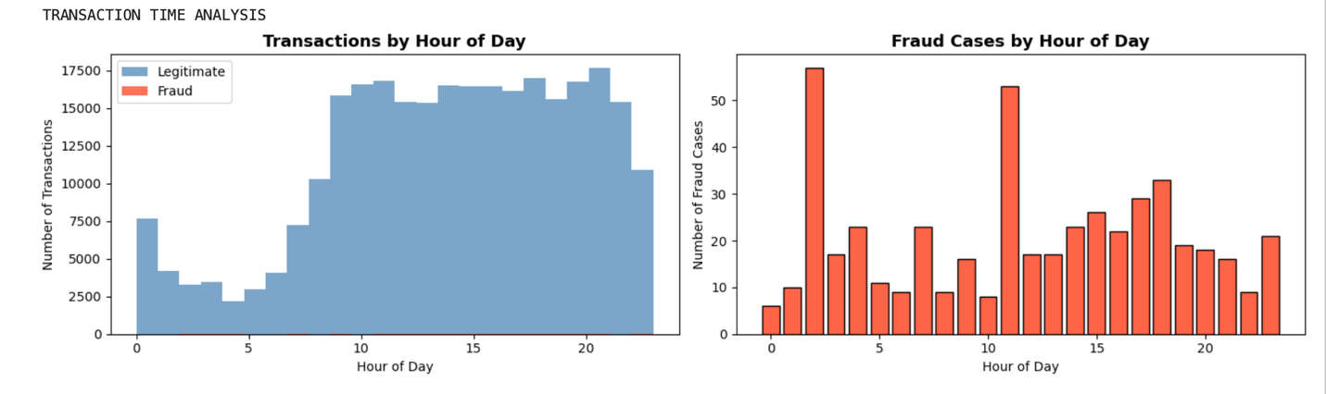
Correlation Analysis: We computed the correlation of each feature with the target variable (Class). Features V14, V17, V12 and V10 showed the strongest negative correlation with fraud, while V11, V4 and V2 showed positive correlation. These correlations directly informed which features our tree-based models would split on most.
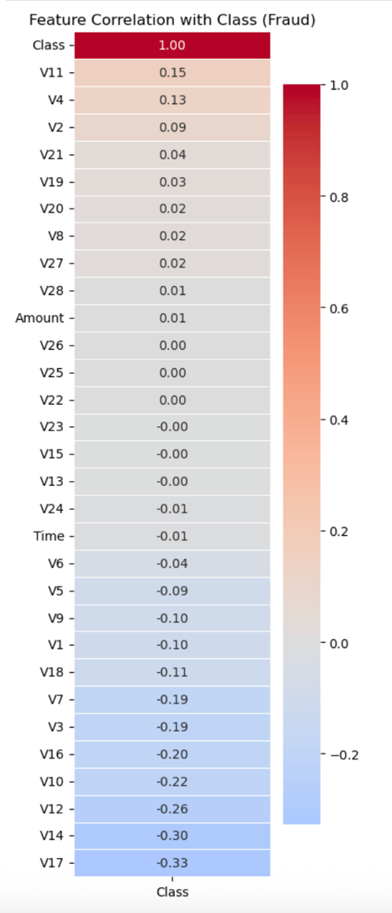
Skewness Assessment: After scaling, we looked at the skewness of all features to decide whether we needed a PowerTransformer. Since V1–V28 are already PCA-transformed, most of them were already pretty close to normally distributed with skewness values mostly under 0.5. We tried adding PowerTransformer and found it made barely any difference, so we left it out. We thought it was better to keep the pipeline simpler and justified rather than adding steps that don't help.
2.3 Data Preprocessing
Getting the preprocessing right is something that required a lot of attention to, especially around the order of operations. It's easy to accidentally introduce data leakage if you're not careful and we wanted to make sure our evaluation results were trustworthy.
Step 1: Cleaning
We removed 1,081 duplicate rows from the dataset to prevent the model from memorizing repeated transactions. The raw Time column was dropped after the Hour feature was derived.
Step 2: Train-Test Split
We split the dataset into 80% training and 20% test sets using with stratify = y sampling to preserve the fraud-to-legitimate ratio in both splits. Critically, this split was performed before any scaling or resampling to prevent data leakage. If we scale on the full dataset first, the scaler has already seen the test set, which means the test evaluation is no longer truly independent.
Step 3: Feature Scaling
StandardScaler was applied to the Amount and Hour features which are the only two non-PCA features that were on different scales from V1–V28. The scaler was fit exclusively on the training set and then applied to the test set, ensuring no test-set statistics influenced the transformation.

Step 4: Synthetic Minority Oversampling Technique (SMOTE)
The training set exhibited a severe 578:1 class imbalance (226,602 legitimate vs. 398 fraud). We applied SMOTE (Synthetic Minority Oversampling Technique) exclusively to the training set, generating synthetic fraud samples by interpolating between real fraud cases in feature space. After SMOTE, the training set was perfectly balanced at 226,602 samples per class. The test set was left untouched to reflect real-world conditions. This is better than random oversampling because it creates genuinely new data points and better than undersampling because we're not throwing away any of the legitimate transaction data.
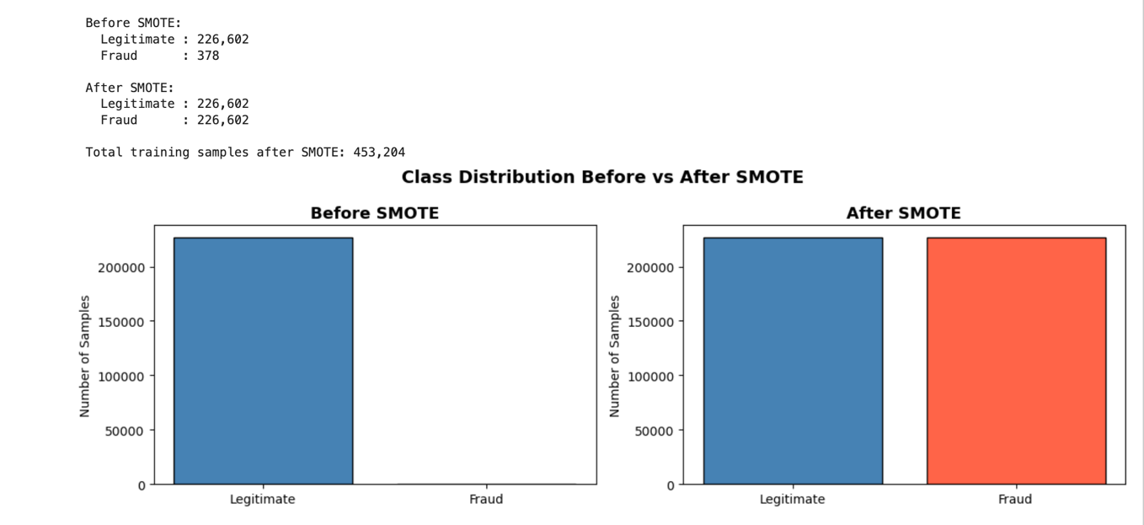

2.3 Model Selection
We selected four supervised classification algorithms that collectively cover a wide spectrum of ML approaches.
1.Logistic Regression
This model serves as our interpretable baseline. It models fraud probability via a logistic function applied to a linear combination of features. Despite its simplicity, it is known to perform well on well-scaled, high-dimensional data and provides a meaningful benchmark. We used GridSearchCV with StratifiedKFold (5 folds) to tune the regularization parameter C across the range [0.01, 0.1, 1, 10, 100], optimizing for ROC-AUC.
2.Decision Tree
This is the most interpretable model in our project. It builds binary splits based on feature thresholds, and its structure can be directly visualized, allowing us to see exactly which features and values drive each fraud prediction. This is helpful for explaining model behavior to non-technical stakeholders. We tuned max_depth, min_samples_split, and min_samples_leaf via GridSearchCV. Notably, Decision Trees do not require feature scaling since they use threshold-based splits rather than distance calculations.
3.Random Forest
It is an ensemble method that trains multiple decision trees on random bootstrap samples with random feature subsets. The diversity among trees reduces overfitting compared to a single Decision Tree and provides strong generalization on complex, noisy data. An additional benefit is featuring importance scores, which quantify each PCA component's contribution to fraud prediction. Due to computational constraints on a 450K SMOTE-balanced dataset, Random Forest was trained with fixed hyperparameters (n_estimators=50, max_depth=10, min_samples_leaf=50).
4.K-Nearest Neighbors (KNN)
This model classifies each transaction by majority vote among its k nearest neighbors in feature space. This is well-suited to fraud detection because fraudulent transactions tend to cluster together in feature space, a direct application of the clustering intuition from unsupervised learning. Proper feature scaling is essential for KNN since it uses Euclidean distance. KNN was trained on the original pre-SMOTE training data due to memory and computational constraints, with k=5.

2.4 Evaluation Metrics
Given the severe class imbalance, we used the following metrics rather than accuracy:
- Precision: Of all transactions predicted as fraud, what fraction were genuinely fraudulent? High precision = fewer false alarms.
- Recall (Sensitivity): Of all actual fraud cases, what fraction did the model catch? High recall = fewer missed frauds.
- F1-Score: The harmonic mean of Precision and Recall. Our primary metric which provides a single balanced measure of both.
- ROC-AUC: Area Under the ROC Curve. Measures the model's ability to discriminate between classes across all classification thresholds, regardless of the chosen cutoff point.
For each model, we plotted a confusion matrix (visualized as a heatmap) and an ROC curve with the random classifier diagonal baseline.

3. Description of Dataset
The dataset used in this project is the Credit Card Fraud Detection dataset published by the Machine Learning Group at Université Libre de Bruxelles (ULB), publicly available on Kaggle.
Download Link: https://www.kaggle.com/datasets/mlg-ulb/creditcardfraud
Key Statistics:
- Total transactions: 284,807 over two days in September 2013 by European cardholders
- Fraudulent transactions: 492 (approximately 0.172%), highly imbalanced binary classification
- File size: approximately 150 MB (exceeds course requirement of ≥100 MB and ≥50,000 rows)
- After removing duplicates: 283,726 rows
Features (31 columns total):
- V1–V28: PCA-transformed numerical features. The original features were transformed using Principal Component Analysis to protect cardholder confidentiality. These 28 components capture the underlying structure of the transaction data without exposing sensitive information.
- Time: Seconds elapsed since the first transaction in the dataset. We derived a more interpretable Hour-of-Day feature (0–23) from this column, then dropped the raw Time feature.
- Amount: The transaction value in Euros. This is one of two non-PCA features we can interpret directly.
- Class: The binary target variable. 1 = Fraudulent, 0 = Legitimate.
Data Quality:
- No missing values across any of the 31 columns.
- 1,081 duplicate rows were identified and removed during preprocessing.
- All features are numeric. No categorical encoding was required.
- The Amount feature had significant right skew (skew = 17.29 before scaling), addressed via StandardScaler.
The dataset's PCA transformation means that V1–V28 are already approximately normally distributed and on a similar numeric scale, which simplified preprocessing considerably. However, the extreme class imbalance (578:1 ratio) remained the central challenge.

4. Results and Analysis

4.1 Exploratory Data Analysis Results
The EDA revealed several important insights that directly informed our modeling decisions:
Class imbalance confirmed: With only 492 fraud cases among 284,807 transactions, the dataset has a 578:1 class imbalance. This confirmed that SMOTE was essential and that accuracy would be a misleading metric throughout.
Amount patterns: Fraudulent transactions showed a median amount of $9.25 compared to $22.00 for legitimate transactions, with a maximum of $2,125.87 compared to $25,691.16. This confirms the known behavioral pattern where fraudsters deliberately keep transaction amounts small to avoid detection thresholds.
Temporal patterns: The Hour-of-Day analysis revealed that fraud peaks significantly at hours 2 and 11, late night and mid-morning while legitimate transaction volume is lowest at night. This suggests that fraud tends to occur when monitoring systems may be less actively staffed.
Feature correlations: V14 (correlation = -0.30) and V17 (correlation = -0.33) showed the strongest negative correlations with fraud. V11 (correlation = +0.15) showed the strongest positive correlation. These findings were later confirmed by the Random Forest feature importance plot, which ranked V14 as the most important feature by a significant margin and consistent with the Decision Tree, which used V14 as its root split.
Correlation findings: V14 and V17 had the strongest negative correlations with fraud (r = -0.30 and -0.33 respectively), and V11 had the strongest positive correlation (r = +0.15). We flagged these going into modeling and weren't surprised when they all showed up as top features in the Random Forest importance chart. It felt like the EDA and the models were telling the same story, just from different angles.
Skewness check: Most features were already close to Gaussian after scaling. We tested PowerTransformer and found minimal improvement, so we cut it from the pipeline. No point adding complexity if it doesn't help.

4.2 Model Results
1. Logistic Regression:
- Precision: 0.0520 | Recall: 0.8737 | F1-Score: 0.0981 | ROC-AUC: 0.9628
- Logistic Regression achieved the highest Recall among all models, catching 87.37% of all fraud cases in the test set. This strong recall performance reflects the effectiveness of SMOTE and the class_weight='balanced' setting. However, the very low Precision (0.0520) indicates that for every genuine fraud alert, the model generates approximately 18 false alarms, flagging legitimate transactions as fraudulent. This makes Logistic Regression impractical as a standalone system without threshold tuning, but valuable as a high-sensitivity layer in a multi-stage detection system.
- The confusion matrix shows 83 true positives and 12 false negatives (missed frauds), alongside 1,647 false positives. Its ROC-AUC of 0.9628 demonstrates strong overall discriminative ability.

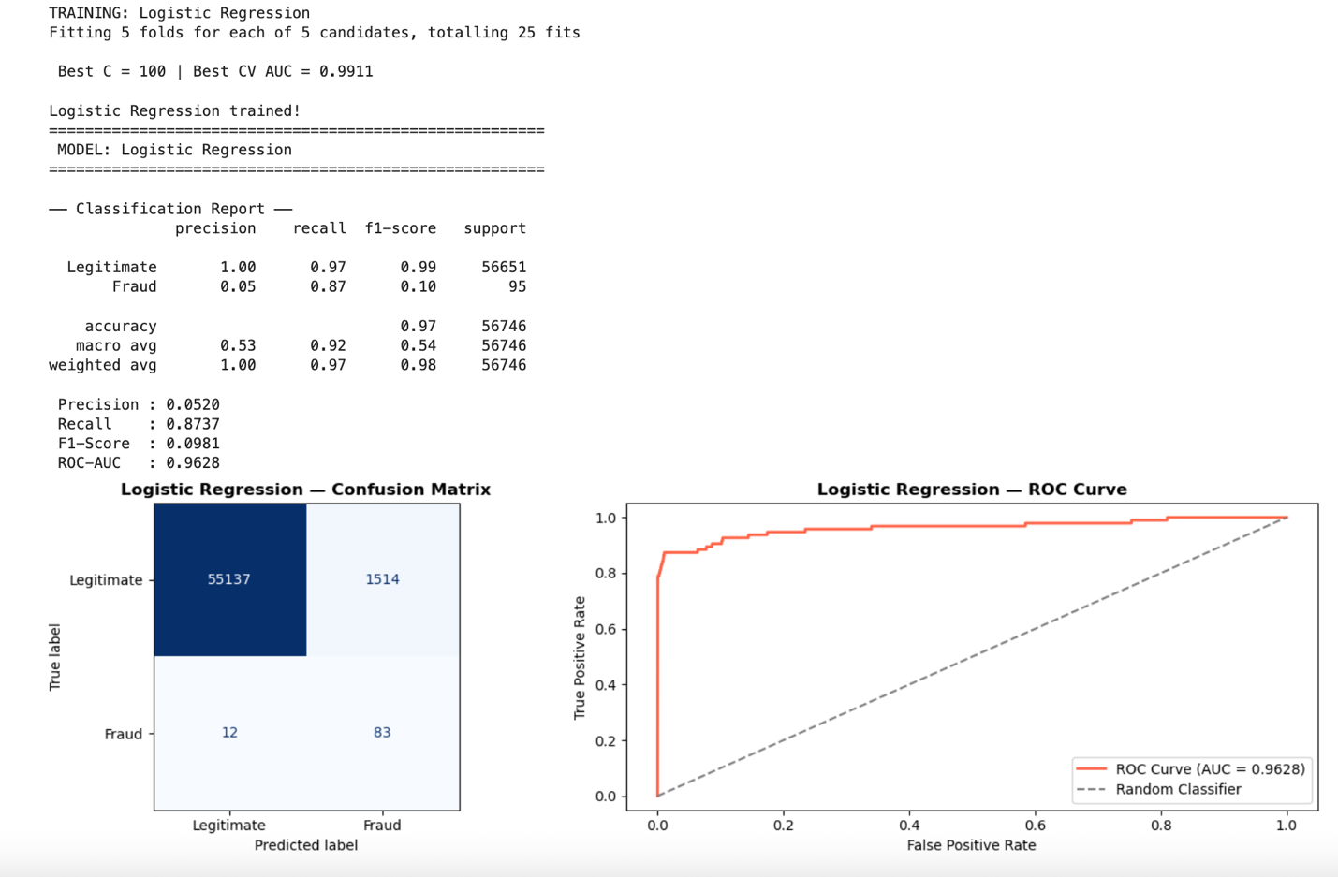

2.Decision Tree:
- Precision: 0.0558 | Recall: 0.8421 | F1-Score: 0.1047 | ROC-AUC: 0.9374
- The Decision Tree's most notable contribution is interpretability. The tree structure visualization shows that V14 ≤ -1.791 is the root split, perfectly consistent with the correlation heatmap identifying V14 as most negatively correlated with fraud. Subsequent splits on V4, V10, V11, V12, V13, and V7 align with other high-correlation features. This transparency makes the Decision Tree uniquely valuable for regulatory compliance and stakeholder explanation, even though its performance metrics were the lowest of the four models. The Decision Tree's lower ROC-AUC (0.9374) suggests that a single tree's axis-aligned splits are insufficient to capture the full complexity of fraud patterns in this 30-dimensional feature space.
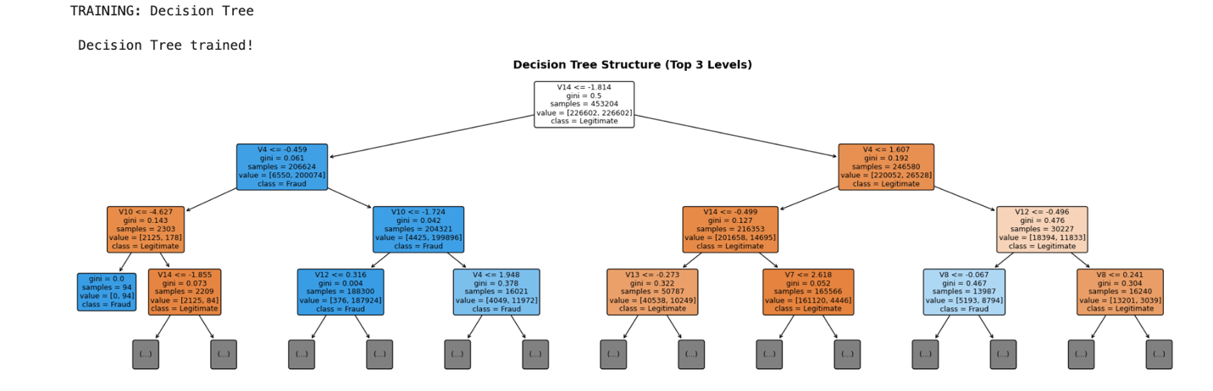

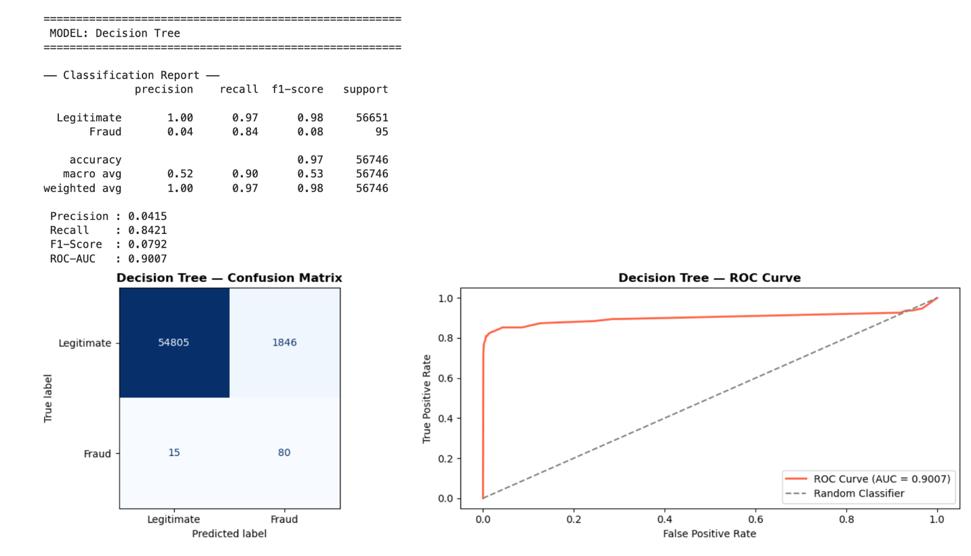
3.Random Forest:
- Precision: 0.3798 | Recall: 0.8316 | F1-Score: 0.5215 | ROC-AUC: 0.9812
- Random Forest achieved the highest ROC-AUC (0.9812) of all four models, demonstrating the best overall discrimination ability across all possible classification thresholds. Its F1-Score of 0.5215 reflects a reasonable balance between Precision and Recall, though it was outperformed by KNN on both metrics. The feature importance plot confirmed V14 as the dominant predictor (importance score ≈ 0.22), followed by V10, V17, V4, and V12, fully consistent with the EDA correlation analysis and the Decision Tree structure. This cross-validation of feature importance across multiple model types strengthens confidence in these findings.
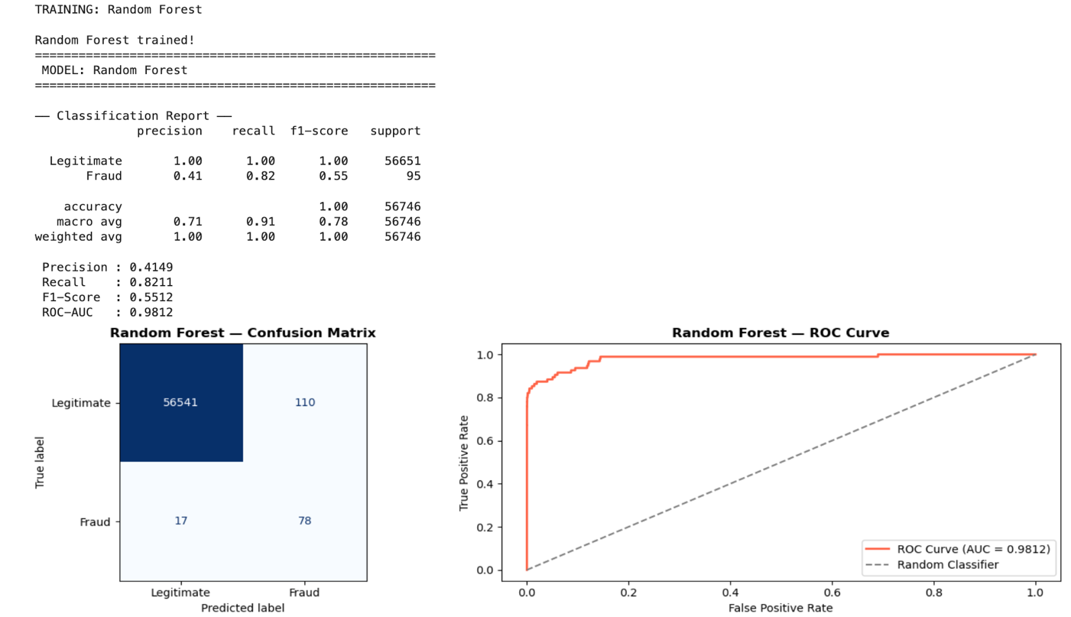
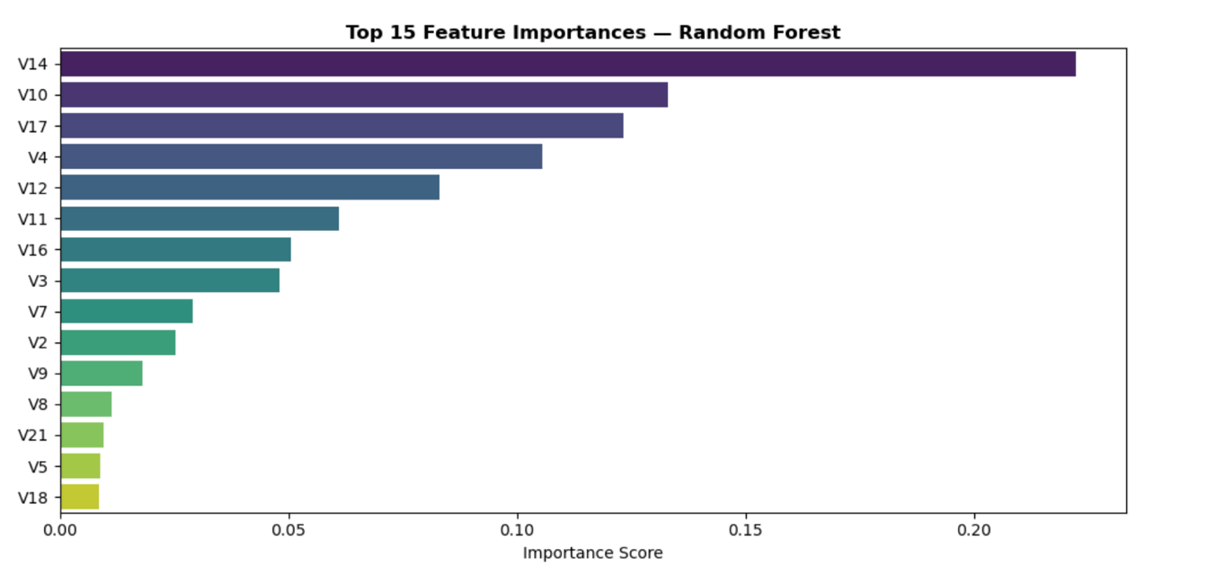
4.K-Nearest Neighbors:
- Precision: 0.9710 | Recall: 0.7053 | F1-Score: 0.8171 | ROC-AUC: 0.8999
- KNN achieved the highest F1-Score (0.8171) and the highest Precision (0.9710) of all four models by a substantial margin. Its confusion matrix showed only 3 false positives, meaning 97.1% of KNN's fraud alerts were genuine fraud cases. This exceptional precision makes KNN highly actionable for fraud investigation teams: analysts can trust that nearly every flagged transaction warrant investigation, dramatically improving operational efficiency. The lower Recall (0.7053) relative to other models means it misses approximately 30% of fraud cases, which represents a tradeoff that can be adjusted via threshold tuning.

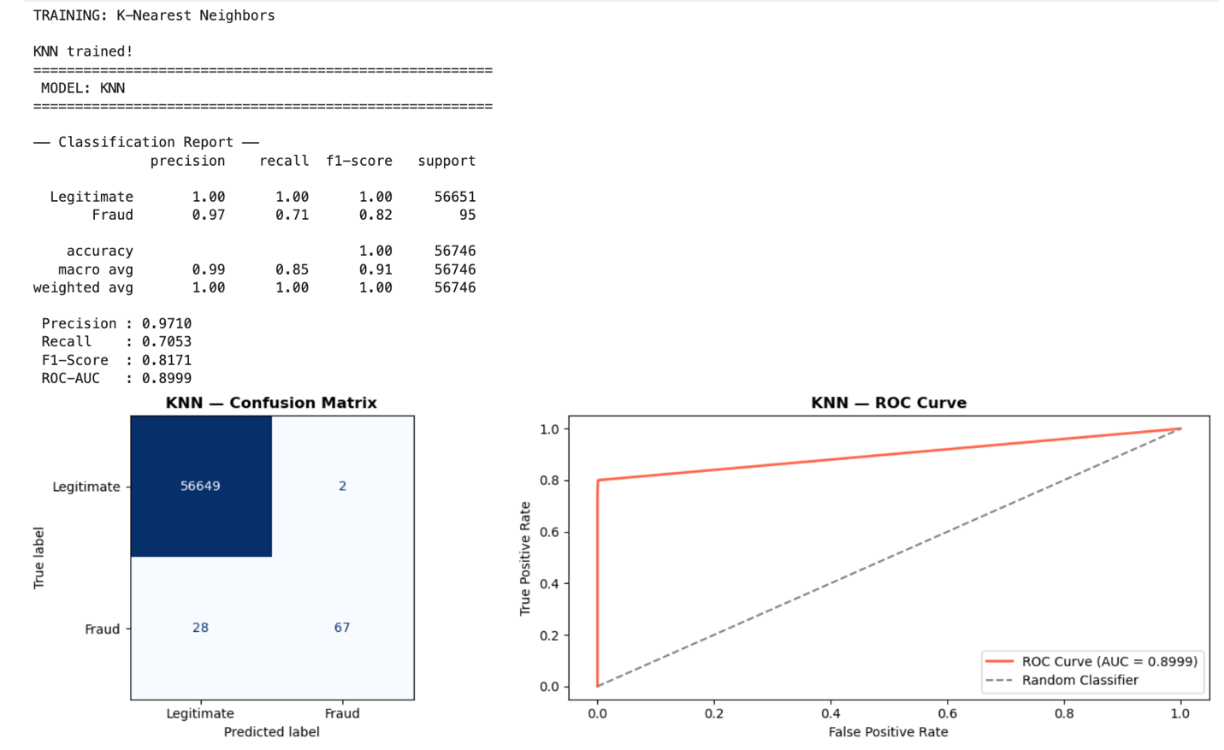

4.3 Model Comparison

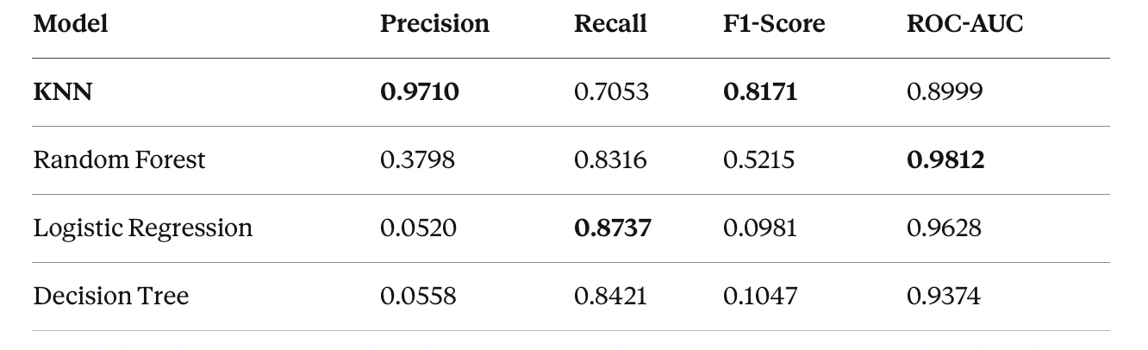

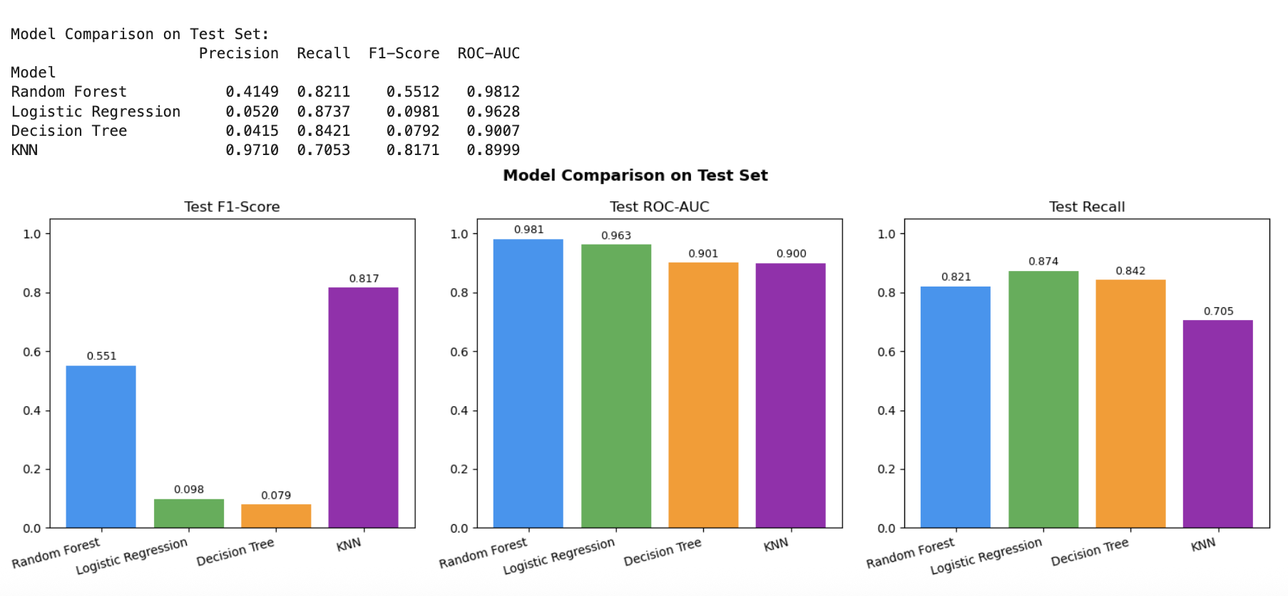
The results reveal a clear precision-recall tradeoff across the four models. Logistic Regression and Decision Tree both achieve high recall but very low precision since they catch most fraud but generate overwhelming false alarm volumes. Random Forest strikes a middle ground with strong ROC-AUC and moderate F1-Score. KNN achieves the best F1-Score and exceptional precision at the cost of somewhat lower recall.

4.4 Why KNN is the Recommended Model
KNN is selected as our recommended model based on its F1-Score of 0.8171, the highest among all four models and significantly above Random Forest's 0.5215. F1-Score is the most appropriate primary metric for this problem because it balances both Precision and Recall, reflecting the real-world cost structure of fraud detection where both missed frauds (false negatives) and excessive false alarms (false positives) carry significant costs.
KNN's precision of 0.9710 is particularly significant from an operational perspective. Fraud investigation is expensive where each flagged transaction requires human review. A system that generates 18 false alarms for every genuine fraud (Logistic Regression's ratio) is operationally unsustainable at scale. KNN's near-perfect precision means investigation resources are deployed efficiently.
Random Forest is recommended as a secondary model for high-risk deployment scenarios where maximizing fraud catch rate is the overriding priority, as its ROC-AUC of 0.9812 allows flexible threshold adjustment to push recall higher at the cost of more false positives.

5. Conclusion
We developed a complete, end-to-end machine learning project for credit card fraud detection using real-world transaction data. We addressed the main challenge of severe class imbalance through SMOTE oversampling, applied rigorous preprocessing including duplicate removal and feature scaling, and trained four supervised classifiers: Logistic Regression, Decision Tree, Random Forest and K-Nearest Neighbors.
All models were evaluated using Precision, Recall, F1-Score and ROC-AUC rather than accuracy, reflecting the unsuitability of accuracy as a metric for imbalanced classification problems. A model that always predicts "legitimate" would achieve 99.83% accuracy while catching zero fraud, the very baseline our models must meaningfully exceed.
KNN emerged as the recommended model with the highest F1-Score (0.8171) and exceptional Precision (0.9710), making it the most operationally practical choice for real-world deployment. Random Forest led in ROC-AUC (0.9812) and serves as the best option when threshold tuning is needed to prioritize recall in high-risk scenarios. Logistic Regression provides the highest recall (0.8737) and is valuable as a high-sensitivity first-stage filter. Decision Tree, while lowest in performance metrics, provides unmatched interpretability through its visual tree structure, making it indispensable for regulatory explanation and stakeholder communication.
Key lessons from this project include the critical importance of evaluation metric selection in imbalanced settings, the value of SMOTE for preserving majority class information while balancing training data, and the insight that no single model is universally best. The optimal choice depends on the specific cost structure and operational constraints of the deployment environment.
If we were to extend this work, we'd explore more advanced techniques like XGBoost or neural networks, try more sophisticated threshold optimization strategies and look at whether combining models in an ensemble pipeline (using LR as a filter, KNN as a classifier) could push performance even further. But as a foundation, we're satisfied that this pipeline is solid, well-justified, and produces genuinely useful results.

6. References
- Dal Pozzolo, A., Caelen, O., Johnson, R. A., & Bontempi, G. (2015). Calibrating probability with undersampling for unbalanced classification. IEEE Symposium Series on Computational Intelligence (SSCI).
- Kaggle Dataset: Credit Card Fraud Detection — Machine Learning Group, Université Libre de Bruxelles (ULB). Available at: https://www.kaggle.com/datasets/mlg-ulb/creditcardfraud
- Chawla, N. V., Bowyer, K. W., Hall, L. O., & Kegelmeyer, W. P. (2002). SMOTE: Synthetic Minority Over-sampling Technique. Journal of Artificial Intelligence Research, 16, 321–357.
- Pedregosa, F., et al. (2011). Scikit-learn: Machine Learning in Python. Journal of Machine Learning Research, 12, 2825–2830. Available at: https://scikit-learn.org
- Lemaître, G., Nogueira, F., & Aridas, C. K. (2017). Imbalanced-learn: A Python Toolbox to Tackle the Curse of Imbalanced Datasets in Machine Learning. Journal of Machine Learning Research, 18(17), 1–5. Available at: https://imbalanced-learn.org
- Breiman, L. (2001). Random Forests. Machine Learning, 45(1), 5–32.
- Cover, T., & Hart, P. (1967). Nearest neighbor pattern classification. IEEE Transactions on Information Theory, 13(1), 21–27.
- James, G., Witten, D., Hastie, T., & Tibshirani, R. (2013). An Introduction to Statistical Learning. Springer.

7.PPT Link:

https://gamma.app/docs/Credit-Card-Fraud-Detection--z45q9as6r83xvul

